# 



|  |  |
| --- | --- |
| Course title: | OOP(Theory) |
| Assignment number: | 04 |
| Submitted by: | Mian Danial Wajid  Husnain Ali  Hafsa Riaz |
| Registration number: | SP23-BSE-092  SP23-BSE-077  SP23-BSE-068 |
| Section: | B |
| Date of submission: | 17th December, 2023 |

Submitted to: Mam Muntaha Iqbal

Contents

04 1

New Features: 3

Classes: 3

1.Interface Fare: 3

2.Ticket class: 3

3.Reservation Class 5

4.Passenger Class 5

5.Flight Class 6

6.feedback(changes made) 8

7.Economic class: 9

8.Business class: 9

9.FirstClass class: 10

10.Airport class 11

11.invalid rating exception class: 12

12.emptyfieldException class: 12

13.cargo(new feature): 12

14.Gui Class named HelloApplication (with file handling): 15

new Features 42

1.Ticket Printing 42

2.Flight schedule printing 43

Press button to print flight schedule 43

3.feedback record maintenance: 44

4.Cargo (new feature) 45

Helps you determine you delivery fare of your parcel at one touch , you can visit our offices to get the parcel booked. 45

UML diagram 46

New UML 47

# 

# New Features:

* Calculation of cargo fare added.

File Handling:-

* Flight Schedule printing
* Feedback record maintained on files.
* Ticket Information print

# Classes:

# 1.Interface Fare:

package com.example.myfx;

public interface Fare {

    static double baseFare=10000;

    static double tax=15000;

    static double discount=10000;

    public double CalculateFare(); // Method for calculating fare and

}

# 2.Ticket class:

package com.example.myfx;

import java.util.ArrayList;

public class Ticket {

    private String reservationNumber;

    ArrayList<Passenger> passengersList;

    ArrayList<Flight> FlightList;

    private double fare;

    public Ticket(String reservationNumber, ArrayList<Passenger> passengersList,

            ArrayList<Flight> flightList) {

        this.reservationNumber = reservationNumber;

        this.passengersList = passengersList;

        FlightList = flightList;

    }

    public double getFare() {

        return fare;

    }

    public String getReservationNumber() {

        return reservationNumber;

    }

    public ArrayList<Passenger> getPassengersList() {

        return passengersList;

    }

    public ArrayList<Flight> getFlightList() {

        return FlightList;

    }

    public static double handleTicketClass(String passName, String email, Long number, int age, String ticketClass, double flightDuration) {    // Static method to handle ticket class and calculate fare

        double fare=0.0;

        if (ticketClass.equalsIgnoreCase("Economy")) {

          Economic e1 = new Economic(passName, email, number, age, ticketClass, number);

          fare = e1.CalculateFare();

        } else if (ticketClass.equalsIgnoreCase("Business")) {

          Business b1 = new Business(passName, email, number, age, ticketClass, number);

          fare = b1.CalculateFare();

        } else if (ticketClass.equalsIgnoreCase("FirstClass")) {

          FirstClass first = new FirstClass(passName, email, number, age, ticketClass, number);

          fare = first.CalculateFare();

        }

        return fare;

    }

}

# 3.Reservation Class

package com.example.myfx;

import java.util.ArrayList;

public class Reservation {

    private String reservationNumber;

    ArrayList<Flight> flightList;

    ArrayList<Passenger> passengersList;

    ArrayList<Ticket>  TicketList;

    public Reservation(String reservationNumber, ArrayList<Flight> flightList, ArrayList<Passenger> passengersList,

            ArrayList<Ticket> ticketList) {

        this.reservationNumber = reservationNumber;

        this.flightList = flightList;

        this.passengersList = passengersList;

        TicketList = ticketList;

    }

    public String getReservationNumber() {

        return reservationNumber;

    }

    public ArrayList<Flight> getFlightList() {

        return flightList;

    }

    public ArrayList<Passenger> getPassengersList() {

        return passengersList;

    }

    public ArrayList<Ticket> getTicketList() {

        return TicketList;

    }

}

# 4.Passenger Class

package com.example.myfx;

public class Passenger {

private String  name;

private String  email;

private long  PhoneNumber;

private int  age;

private String ticketClass;

    public Passenger(String name, String email, long phoneNumber, int age, String ticketClass) {

    this.name = name;

    this.email = email;

    PhoneNumber = phoneNumber;

    this.age = age;

    this.ticketClass = ticketClass;

}

    public String getName() {

        return name;

    }

    public String getEmail() {

        return email;

    }

    public long getPhoneNumber() {

        return PhoneNumber;

    }

    public int getAge() {

        return age;

    }

    public String getTicketClass() {

        return ticketClass;

    }

}

# 5.Flight Class

package com.example.myfx;

import java.util.Date;

import java.util.ArrayList;

public class Flight {

    private String flightNumber;

    private Date departureTime;

    private Date arrivalTime;

    private double flightDuration;

    private String departueAirport;

    private String destinationAirport;

    public Flight(String flightNumber, Date departureTime, Date arrivalTime, double flightDuration,

            String departueAirport, String destinationAirport) {

        this.flightNumber = flightNumber;

        this.departureTime = departureTime;

        this.arrivalTime = arrivalTime;

        this.flightDuration = flightDuration;

        this.departueAirport = departueAirport;

        this.destinationAirport = destinationAirport;

    }

    public String getFlightNumber() {

        return flightNumber;

    }

    public Date getDepartureTime() {

        return departureTime;

    }

    public Date getArrivalTime() {

        return arrivalTime;

    }

    public double getFlightDuration() {

        return flightDuration;

    }

    public String getDepartueAirport() {

        return departueAirport;

    }

    public String getDestinationAirport() {

        return destinationAirport;

    }

    public static void displayFlightSchedule(ArrayList<Flight> FlightList) {        // Static method to display the flight schedule

        if (FlightList.isEmpty()) {

            System.out.println("No flights available.");

            return;

        }

        System.out.println("----Flight Schedule----");

        for (int i = 0; i < FlightList.size(); i++) {

            Flight flight = FlightList.get(i);

            System.out.println("Flight Number: " + flight.getFlightNumber());

            System.out.println("Destination Airport: " + flight.getDestinationAirport());

            System.out.println("Departure Airport: " + flight.getDepartueAirport());

            System.out.println("Arrival Time: " + flight.getArrivalTime());

            System.out.println("Departure Time: " + flight.getDepartureTime());

            System.out.println("-----------------------------------------------");

        }

    }

}

# 6.feedback(changes made)

package com.example.myfx;  
  
import java.util.ArrayList;  
import java.util.Date;  
import java.util.List;  
import java.util.Scanner;  
public class Feedback {  
 private String passengerName;  
 private String feedBackContent;  
 private int rating;  
 private String SubmissionDate;  
 public Feedback(String passengerName, String feedBackContent, int rating, String submissionDate) {  
 this.passengerName = passengerName;  
 this.feedBackContent = feedBackContent;  
 if (rating >10 | rating <1){  
 throw new invalidRatingException();  
 }  
 this.rating = rating;  
 SubmissionDate = submissionDate;  
 }  
 public String getPassengerName() {  
 return passengerName;  
 }  
 public String getFeedbackContent() {  
 return feedBackContent;  
 }  
 public int getRating() {  
 return rating;  
 }  
 public String getSubmissionDate() {  
 return SubmissionDate;  
 }   
   
  
 public static void printFeedback(List<Feedback> feedbackList) { // Static method to print a list of feedback  
 int index = 0;  
 for (Feedback f : feedbackList) {  
 index++;  
 System.*out*.println("Review " + index + ":");  
 System.*out*.println("User Name: " + f.passengerName);  
 System.*out*.println("Feedback content: " + f.feedBackContent);  
 System.*out*.println("Rating: " + f.rating);  
 System.*out*.println("Submission Date: " + f.SubmissionDate);  
 System.*out*.println("---------------------------------------------------------");  
 }  
 }  
   
  
  
   
}

# 7.Economic class:

package com.example.myfx;

public class Economic extends Passenger implements Fare {

    // Economic class extends Passenger class and implements Fare interface

    private double flightDuration;

    public Economic(String name, String email, long phoneNumber, int age, String ticketClass, double flightDuration) {

        super(name, email, phoneNumber, age, ticketClass);

        this.flightDuration = flightDuration;

    }

    @Override       // Implementation of the CalculateFare method from the Fare interface

    public  double CalculateFare() {

        return (baseFare*flightDuration) + tax - discount;

    }

    public double getFlightDuration() {

        return flightDuration;

    }

 }

# 8.Business class:

package com.example.myfx;

public class Business extends Passenger implements Fare {         // Business class extends Passenger class and implements Fare interface

     private final double  superTax=12000;

    private double FlightDuration;

    public Business(String name, String email, long phoneNumber, int age, String ticketClass, double flightDuration) {

        super(name, email, phoneNumber, age, ticketClass);

        FlightDuration = flightDuration;

    }

    public double getFlightDuration() {

        return FlightDuration;

    }

    @Override           // Implementation of the CalculateFare method from the Fare interface

    public double CalculateFare() {

        return (baseFare*FlightDuration)+ tax + superTax - discount;

    }

}

# 9.FirstClass class:

package com.example.myfx;

public class FirstClass extends Passenger implements Fare {         // FirstClass class extends Passenger class and implements Fare interface

     private final double superTax=20000;

    private double FlightDuration;

    public FirstClass(String name, String email, long phoneNumber, int age, String ticketClass, double flightDuration) {

        super(name, email, phoneNumber, age, ticketClass);       // Calling the constructor of Passenger class to initialize passenger details

        FlightDuration = flightDuration;

    }

    public double getSuperTax() {

        return superTax;

    }

    public double getFlightDuration() {

        return FlightDuration;

    }

    @Override             // Implementation of the CalculateFare method from the Fare interface

    public double CalculateFare() {

        return (baseFare*FlightDuration) + tax - discount + superTax;

    }

}

# 10.Airport class

package com.example.myfx;

import java.util.ArrayList;

public class Airport {

    private String  airportName;

    private String  code;

    private String  city;

    private String  country;

    public Airport(String airportName, String code, String city, String country) {

        this.airportName = airportName;

        this.code = code;

        this.city = city;

        this.country = country;

    }

    public String getAirportName() {

        return airportName;

    }

    public String getCode() {

        return code;

    }

    public String getCity() {

        return city;

    }

    public String getCountry() {

        return country;

    }

    public static ArrayList<Airport> getArrivalAirports() {                // Static method to get a list of sample Arrival Airports:

        ArrayList<Airport> arrivalAirports = new ArrayList<>();

        arrivalAirports.add(new Airport("Allama Iqbal Airport", "1092", "Lahore", "Pakistan"));

        arrivalAirports.add(new Airport("Jinnah International", "1091", "Karachi", "Pakistan"));

        arrivalAirports.add(new Airport("Multan International", "1094", "Multan", "Pakistan"));

        arrivalAirports.add(new Airport("Faisalabad International", "1082", "Faisalabad", "Pakistan"));

        return arrivalAirports;

    }

    public static ArrayList<Airport> getDepartureAirports() {           // Static method to get a list of  Departure Airports:

        ArrayList<Airport> departureAirports = new ArrayList<>();

        departureAirports.add(new Airport("Benezir Intl Airport", "1091", "Larkana", "Pakistan"));

        departureAirports.add(new Airport("Heathrow Intl Airport", "1091", "London", "United Kingdom"));

        departureAirports.add(new Airport("JFK Airport", "1086", "New York", "USA"));

        departureAirports.add(new Airport("Doha Airport", "1088", "Doha", "Qatar"));

        departureAirports.add(new Airport("Dubai Int Airport", "1066", "Dubai", "UAE"));

        return departureAirports;

    }

}

# 11.invalid rating exception class:

package com.example.myfx;

public class invalidRatingException extends RuntimeException {

    public invalidRatingException() {

    }

# 12.emptyfieldException class:

package com.example.myfx;  
  
public class EmptyFieldException extends RuntimeException {  
 public EmptyFieldException() {  
 super();  
 }  
}

# 13.cargo(new feature):

package com.example.myfx;  
  
public class Cargo{  
 private double weight;  
 private double perkm;  
 private double duration;  
 private String destination;  
 private boolean fastTrack;  
 private String origin;  
  
 public Cargo(double weight, String destination, boolean fastTrack, String origin) {  
 this.weight = weight;  
 this.destination = destination;  
 this.fastTrack = fastTrack;  
 this.origin = origin;  
 }  
  
 public double getWeight() {  
 return weight;  
 }  
  
 public double getPerkm() {  
 return perkm;  
 }  
  
 public double getDuration() {  
 return duration;  
 }  
  
 public String getDestination() {  
 return destination;  
 }  
  
  
 public boolean isFastTrack() {  
 return fastTrack;  
 }  
  
 public void setOrigin(String origin) {  
 this.origin = origin;  
 }  
  
 public static double cargofare(double weight,String destination , boolean isFastTrack, String origin ){  
 double total=0;  
 double duration=0;  
 final double perkm=1000;  
  
 if (destination.equalsIgnoreCase("Islamabad")&&origin.equalsIgnoreCase("Lahore")){  
 duration=1.5;  
 total = weight * perkm * duration ;  
 }else if (destination.equalsIgnoreCase("London")&&origin.equalsIgnoreCase("Lahore")){  
 duration=8.5;  
 total = weight * perkm * duration ;  
 }else if (destination.equalsIgnoreCase("newyork")&&origin.equalsIgnoreCase("Lahore")){  
 duration=22;  
 total = weight * perkm * duration ;  
 }else if (destination.equalsIgnoreCase("doha")&&origin.equalsIgnoreCase("Lahore")){  
 duration=1.5;  
 total = weight * perkm * duration ;  
 }else if (destination.equalsIgnoreCase("dubai")&&origin.equalsIgnoreCase("Lahore")){  
 duration=1.5;  
 total = weight * perkm * duration ;  
 }else if (destination.equalsIgnoreCase("islamabad")&&origin.equalsIgnoreCase("karachi")){  
 duration=1.5;  
 total = weight * perkm * duration ;  
 }else if (destination.equalsIgnoreCase("london")&&origin.equalsIgnoreCase("karachi")){  
 duration=1.5;  
 total = weight * perkm * duration ;  
 }else if (destination.equalsIgnoreCase("newyork")&&origin.equalsIgnoreCase("karachi")){  
 duration=1.5;  
 total = weight * perkm * duration ;  
 }else if (destination.equalsIgnoreCase("doha")&&origin.equalsIgnoreCase("karachi")){  
 duration=1.5;  
 total = weight * perkm * duration ;  
 }else if (destination.equalsIgnoreCase("dubai")&&origin.equalsIgnoreCase("karachi")){  
 duration=1.5;  
 total = weight * perkm * duration ;  
 }else if (destination.equalsIgnoreCase("islamabad")&&origin.equalsIgnoreCase("multan")){  
 duration=1.5;  
 total = weight * perkm * duration ;  
 }else if (destination.equalsIgnoreCase("newyork")&&origin.equalsIgnoreCase("multan")){  
 duration=1.5;  
 total = weight * perkm * duration ;  
 }else if (destination.equalsIgnoreCase("london")&&origin.equalsIgnoreCase("multan")){  
 duration=1.5;  
 total = weight * perkm * duration ;  
 }else if (destination.equalsIgnoreCase("doha")&&origin.equalsIgnoreCase("multan")){  
 duration=1.5;  
 total = weight * perkm * duration ;  
 }else if (destination.equalsIgnoreCase("dubai")&&origin.equalsIgnoreCase("multan")){  
 duration=1.5;  
 total = weight * perkm * duration ;  
 }else if (destination.equalsIgnoreCase("islamabad")&&origin.equalsIgnoreCase("faisalabad")){  
 duration=1.5;  
 total = weight * perkm * duration ;  
 }else if (destination.equalsIgnoreCase("newyork")&&origin.equalsIgnoreCase("faisalabad")){  
 duration=1.5;  
 total = weight * perkm * duration ;  
 }else if (destination.equalsIgnoreCase("doha ")&&origin.equalsIgnoreCase("faisalabad")){  
 duration=1.5;  
 total = weight * perkm * duration ;  
 }else if (destination.equalsIgnoreCase("dubai ")&&origin.equalsIgnoreCase("faisalabad")){  
 duration=1.5;  
 total = weight * perkm * duration ;  
 }else if (destination.equalsIgnoreCase("london ")&&origin.equalsIgnoreCase("faisalabad")){  
 duration=1.5;  
 total = weight * perkm * duration ;  
 }  
 if (isFastTrack){  
 total+=10000;  
 }  
 return total;  
 }  
}

# 14.Gui Class named HelloApplication (with file handling):

package com.example.myfx;  
  
import javafx.application.Application;  
import javafx.fxml.FXMLLoader;  
import javafx.geometry.Insets;  
import javafx.scene.Scene;  
import javafx.scene.layout.*;  
import javafx.scene.paint.Color;  
import javafx.stage.Stage;  
  
import java.io.FileNotFoundException;  
import java.io.FileOutputStream;  
import java.io.FileWriter;  
import java.io.IOException;  
import javafx.application.Application;  
import javafx.collections.FXCollections;  
import javafx.collections.ObservableList;  
import javafx.scene.control.cell.PropertyValueFactory;  
import javafx.scene.effect.DropShadow;  
import javafx.scene.text.Font;  
import javafx.scene.text.Text;  
import javafx.scene.text.TextAlignment;  
import javafx.stage.Stage;  
import javafx.scene.Scene;  
import javafx.scene.control.*;  
import javafx.scene.image.Image;  
import javafx.scene.image.ImageView;  
  
import java.nio.file.Paths;  
import java.text.SimpleDateFormat;  
import java.time.LocalDate;  
import java.util.*;  
import java.awt.Desktop;  
import java.net.URI;  
  
  
public class HelloApplication extends Application {  
 Scene scn1, scn2, scn3, scn4, scn5, scn6, scn8, scn9, scn10, scn11,scn12;  
 String selectedFlightNumber;  
 ArrayList<Flight> flightlist = new ArrayList<>();  
 ArrayList<Passenger> passengersList = new ArrayList<>();  
 ArrayList<Ticket> TicketList = new ArrayList<>();  
 ArrayList<Reservation> ReservationList = new ArrayList<>();  
  
 @Override  
 public void start(Stage stage) throws Exception {  
 stage.setTitle("Bcatatic Air Booking System");  
////////////////////Scene 1/////////////////////////////////////////////////////////  
 Button button0 = new Button();  
 Button button1 = new Button("Booking");  
 Button button2 = new Button("Flight Schedule");  
 Button button3 = new Button("Give Feedback");  
 Button button4 = new Button("Our reviews");  
 Button button5 = new Button("About Us ");  
 Button button6 = new Button("Our Destination");  
 Button button7 = new Button("Contact Us");  
 Button button8 = new Button("Cargo");  
  
 GridPane pane1 = new GridPane();  
 pane1.add(button0, 0, 0);  
 pane1.add(button1, 1, 0);  
 pane1.add(button2, 2, 0);  
 pane1.add(button3, 3, 0);  
 pane1.add(button4, 4, 0);  
  
 scn1 = new Scene(pane1, 1200, 700);  
  
 button1.setOnAction(e -> {  
 displayForm(stage);  
  
  
 });  
  
  
 TableView tableView5 = new TableView<>();  
 TableColumn<Flight, String> flightno = new TableColumn<>("Flight Number");  
 flightno.setCellValueFactory(new PropertyValueFactory<>("flightNumber"));  
  
 TableColumn<Flight, String> DestinationAirport = new TableColumn<>("Destination Airport");  
 DestinationAirport.setCellValueFactory(new PropertyValueFactory<>("destinationAirport"));  
  
 TableColumn<Flight, String> DepartureAirport = new TableColumn<>("Departure Airport");  
 DepartureAirport.setCellValueFactory(new PropertyValueFactory<>("departueAirport"));  
  
 TableColumn<Flight, Date> ArrivalTime = new TableColumn<>("Arrival Time");  
 ArrivalTime.setCellValueFactory(new PropertyValueFactory<>("arrivalTime"));  
  
 TableColumn<Flight, Date> DepartureTime = new TableColumn<>("Departure Time");  
 DepartureTime.setCellValueFactory(new PropertyValueFactory<>("departureTime"));  
 ArrayList<Airport> ArrivalAirportList = Airport.*getArrivalAirports*();  
 ArrayList<Airport> DepartueAirportList = Airport.*getDepartureAirports*();  
 Date df = new Date();  
 int flightNumberCounter = 100;  
 double[] flightDuration = {1.5, 2.6, 3.8, 9.8, 15.6, 17.9, 20.2, 5.7, 5.9, 8.34};  
 for (int i = 0; i < ArrivalAirportList.size(); i++) {// Assigning unique flight number and flight duration to eacg flight  
 for (int j = 0; j < DepartueAirportList.size(); j++) {  
 double duration = flightDuration[flightNumberCounter % flightDuration.length];  
 flightNumberCounter++;  
 String flightNumber = "LH" + flightNumberCounter;  
 flightlist.add(new Flight(flightNumber, df, df, duration, ArrivalAirportList.get(i).getAirportName(), DepartueAirportList.get(j).getAirportName()));  
 }  
 }  
 Button printSchedule= new Button("Print Schedule");  
 printSchedule.setOnAction(e->{  
 try {  
 FileWriter writer = new FileWriter("C:/Users/wajid/Desktop/Schedule.txt");  
  
 for (Flight flight : flightlist) {  
 writer.write("Flight Number: " + flight.getFlightNumber() + "\n");  
 for (Airport a: ArrivalAirportList) {  
 writer.write("Arrival Airport: " + a.getAirportName() + "\n");  
 }  
 for (Airport d: DepartueAirportList) {  
 writer.write("Departure Airport: " + d.getAirportName() + "\n");  
 }  
 writer.write("Departure Time: " + flight.getDepartureTime() + "\n");  
 writer.write("Arrival Time: " + flight.getArrivalTime() + "\n");  
 writer.write("\n");  
 }  
 writer.close();  
 } catch (IOException k) {  
 System.*out*.println("print unsuccessfull!");  
 k.printStackTrace();  
 }  
  
  
 });  
  
 tableView5.getColumns().addAll(flightno, DestinationAirport, DepartureAirport, ArrivalTime, DepartureTime);  
 tableView5.setItems(FXCollections.*observableArrayList*(flightlist));  
  
 Button back2 = new Button("Back");  
 back2.setOnAction(e -> stage.setScene(scn1));  
 VBox vBox5 = new VBox(tableView5, back2,printSchedule);  
 setHoverCustomEffect(printSchedule);  
 setHoverCustomEffect(back2);  
  
  
 scn5 = new Scene(vBox5, 1200, 700);  
  
  
 button2.setOnAction(e -> {  
 stage.setScene(scn5);  
 System.*out*.println(flightlist.size());  
 });  
///////////////////////////////////////////////////////////////////////////////////////////////////////////////////////////////////////////////  
  
 //scene 6 feedback  
 Label feedL1 = new Label(" Passenger Name");  
 TextField tx1 = new TextField();  
 Label feedL2 = new Label(" Rating");  
 TextField tx2 = new TextField();  
 Label feedL3 = new Label(" Content");  
 TextField tx3 = new TextField();  
 Label feedL4 = new Label();  
 GridPane pane6 = new GridPane();  
  
 pane6.add(feedL1, 1, 0);  
 pane6.add(tx1, 1, 1);  
 pane6.add(feedL2, 1, 2);  
 pane6.add(tx2, 1, 3);  
 pane6.add(feedL3, 1, 4);  
 pane6.add(tx3, 1, 5);  
 pane6.add(feedL4, 1, 6);  
  
 pane6.setHgap(5);  
 pane6.setVgap(0);  
 Button back3 = new Button("Back");  
 back3.setOnAction(e -> stage.setScene(scn1));  
 iconButton(back3);  
 pane6.add(back3, 2, 6);  
 scn6 = new Scene(pane6, 1200, 700);  
 button3.setOnAction(e -> stage.setScene(scn6));  
 Button feedsub = new Button("Submit");  
  
 TableView<Feedback> tableView = new TableView<>();  
 ArrayList<Feedback> feedbackList = new ArrayList<>();  
  
 Label label61 = new Label(" Your feedback is valuable for us!");  
 pane6.add(label61, 1, 7);  
  
 feedsub.setOnAction(e -> {  
 try {  
 String name = tx1.getText();  
 int rating = Integer.*parseInt*(tx2.getText());  
 String content = tx3.getText();  
 Date d1 = new Date();  
 String dd1 = d1.toString();  
 feedbackList.add(new Feedback(name, content, rating,dd1));  
 FileOutputStream obj = new FileOutputStream("C:/Users/wajid/Desktop/Feedback.txt", true);  
 Formatter myfile = new Formatter(obj);  
 myfile.format("\n%s, %s, %d, %s",name,content,rating,dd1);  
 myfile.close();  
  
  
 label61.setText(" Thank you for your feedback !");  
  
 System.*out*.println(feedbackList.size());  
 tableView.setItems(FXCollections.*observableArrayList*(feedbackList));  
  
  
  
 tx1.setText("");  
 tx2.setText("");  
 tx3.setText("");  
  
 } catch (NumberFormatException ex) {  
 ErrorAlertMethod("Error", "Invalid rating. Please enter a valid rating.");  
  
 tx1.setText("");  
 tx2.setText("");  
 tx3.setText("");  
  
 } catch (Exception ex) {  
 ErrorAlertMethod("Error", "An unexpected error occurred.");  
 ex.printStackTrace();  
 }  
 });  
  
 ImageView imageView3 = new ImageView( new Image("file:/E://algorithms 1//MyFx//src//main//java//com//example//myfx//WhatsApp Image 2023-12-07 at 8.21.22 PM.jpeg"));  
 Pane pane11 = new Pane();  
 tx3.setStyle("-fx-padding: 0;");  
 tx3.setStyle("-fx-margin: 0;");  
 pane11.getChildren().addAll(imageView3, back3, feedsub, pane6);  
 scn6 = new Scene(pane11, 800, 750);  
 imageView3.fitWidthProperty().bind(scn6.widthProperty());  
 imageView3.fitHeightProperty().bind(scn6.heightProperty());  
 feedL1.setStyle("-fx-padding: 0; -fx-margin: 0;");  
 feedL2.setStyle("-fx-padding: 0; -fx-margin: 0;");  
  
 setHeight(back3);  
 back3.setPrefWidth(200);  
 back3.setLayoutX(15);  
 back3.setLayoutY(400);  
 setHoverCustomEffect(back3);  
 feedL1.setStyle("-fx-text-fill: black; -fx-background-color: yellow;");  
 feedL1.setPrefWidth(200);  
  
 setHeight(feedsub);  
 feedsub.setPrefWidth(200);  
 feedsub.setLayoutX(15);  
 feedsub.setLayoutY(300);  
 setHoverCustomEffect(feedsub);  
 feedL1.setStyle("-fx-text-fill: black; -fx-background-color: #FFD700; -fx-background-radius: 0;");  
 feedL1.setPrefWidth(210);  
 feedL1.setPrefHeight(50);  
 feedL2.setStyle("-fx-text-fill: black; -fx-background-color: #FFD700; -fx-background-radius: 0;");  
 feedL2.setPrefWidth(210);  
 feedL2.setPrefHeight(50);  
 feedL3.setStyle("-fx-text-fill: black; -fx-background-color: #FFD700; -fx-background-radius: 0;");  
 feedL3.setPrefWidth(210);  
 feedL3.setPrefHeight(50);  
 label61.setStyle("-fx-text-fill: black; -fx-background-color: #FFD700; -fx-background-radius: 0;");  
 label61.setPrefWidth(210);  
 label61.setPrefHeight(50);  
 tx1.setStyle("-fx-background-color: transparent;");  
 tx2.setStyle("-fx-background-color: transparent;");  
 tx3.setStyle("-fx-background-color: transparent;");  
  
  
 //scene 7 reviews  
 try {  
 Scanner scanner= new Scanner(Paths.*get*("C:/Users/wajid/Desktop/Feedback.txt"));  
  
 while (scanner.hasNext()) {  
 String line = scanner.nextLine();  
 Scanner obj = new Scanner(line);  
 obj.useDelimiter(",\\s");  
 try {  
 String passengerName = obj.next();  
 String feedbackContent = obj.next();  
 int rating = obj.nextInt();  
 String dateString = obj.nextLine().trim();  
  
 Feedback feedback = new Feedback(passengerName, feedbackContent, rating, dateString);  
 feedbackList.add(feedback);  
 tableView.getItems().add(feedback);  
  
 } catch (NoSuchElementException e) {  
 e.getMessage();  
 } finally {obj.close();  
 }  
 }  
 System.*out*.println("feedback list size :"+feedbackList.size());  
 }catch (IOException e) {  
 e.getMessage();  
 }catch (NoSuchElementException e){  
 e.getMessage();  
 }  
 TableColumn<Feedback, String> nameColumn = new TableColumn<>("Passenger Name");  
 nameColumn.setCellValueFactory(new PropertyValueFactory<>("passengerName"));  
  
 TableColumn<Feedback, String> contentColumn = new TableColumn<>("Feedback Content");  
 contentColumn.setCellValueFactory(new PropertyValueFactory<>("feedbackContent"));  
  
 TableColumn<Feedback, Integer> ratingColumn = new TableColumn<>("Rating");  
 ratingColumn.setCellValueFactory(new PropertyValueFactory<>("rating"));  
  
 TableColumn<Feedback, Date> dateColumn = new TableColumn<>("Submission Date");  
 dateColumn.setCellValueFactory(new PropertyValueFactory<>("submissionDate"));  
 Button back7 = new Button("Back");  
 tableView.getColumns().addAll(nameColumn, contentColumn, ratingColumn, dateColumn);  
 tableView.getItems().addAll(feedbackList);  
 VBox vbox = new VBox(tableView, back7);  
 Scene scn7 = new Scene(vbox, 1200, 700);  
 button4.setOnAction(e -> stage.setScene(scn7));  
 setHeight(back7);  
 back7.setPrefWidth(200);  
 setHoverCustomEffect(back7);  
 back7.setOnAction(e -> stage.setScene(scn1));  
 tableView.setItems(FXCollections.*observableArrayList*(feedbackList));  
 //scene 8  
  
 ImageView imageView8 = new ImageView(new Image("file:E:/algorithms 1/MyFx/src/main/java/com/example/myfx/top-view-frame-with-plane-sweets.jpg"));  
 Text text80 = new Text("About us ");  
 text80.setStyle("-fx-font-family: 'Lucida Handwriting'; -fx-font-size: 50;");  
 Text airlineInfo1 = new Text(" Welcome aboard our airline! We're all about making your travel experience extraordinary .");  
 Text airlineInfo2 = new Text(" From the moment you step onto our planes,we're here to take you on a journey filled with ");  
 Text airlineInfo3 = new Text("convenience, and a touch of adventure. At our airline, we believe that flying should be");  
 Text airlineInfo4 = new Text(" more than just a means of transportation . It should be a opportunity to explore new");  
 Text airlineInfo5 = new Text("It should be a opportunity to explore new horizons, connect with loved ones,and create");  
 Text airlineInfo6 = new Text(" unforgettable memories. That's why we're committed to providing top-notch service that");  
 Text airlineInfo7 = new Text(" goes above and beyond your expectations.With a fleet of modern and reliable aircraft, we");  
 Text airlineInfo8 = new Text(" prioritize your safety above all.");  
 airlineInfo1.setStyle("-fx-font-family: 'Lucida Handwriting'; -fx-font-size: 12;");  
 airlineInfo2.setStyle("-fx-font-family: 'Lucida Handwriting'; -fx-font-size: 12;");  
 airlineInfo3.setStyle("-fx-font-family: 'Lucida Handwriting'; -fx-font-size: 12;");  
 airlineInfo4.setStyle("-fx-font-family: 'Lucida Handwriting'; -fx-font-size: 12;");  
 airlineInfo5.setStyle("-fx-font-family: 'Lucida Handwriting'; -fx-font-size: 12;");  
 airlineInfo6.setStyle("-fx-font-family: 'Lucida Handwriting'; -fx-font-size: 12;");  
 airlineInfo7.setStyle("-fx-font-family: 'Lucida Handwriting'; -fx-font-size: 12;");  
 airlineInfo8.setStyle("-fx-font-family: 'Lucida Handwriting'; -fx-font-size: 12;");  
  
  
 text80.setFont(Font.*font*("Serif", 50));  
 text80.setY(150);  
 text80.setX(700);  
 airlineInfo1.setX(700);  
 airlineInfo1.setY(190);  
 airlineInfo2.setX(700);  
 airlineInfo2.setY(210);  
 airlineInfo3.setX(700);  
 airlineInfo3.setY(230);  
 airlineInfo4.setX(700);  
 airlineInfo4.setY(250);  
 airlineInfo5.setX(700);  
 airlineInfo5.setY(270);  
 airlineInfo6.setX(700);  
 airlineInfo6.setY(290);  
 airlineInfo7.setX(700);  
 airlineInfo7.setY(310);  
 airlineInfo8.setX(700);  
 airlineInfo8.setY(330);  
  
  
 Pane pane8 = new Pane();  
 ImageView imageView8back = new ImageView(new Image("file:/E:/algorithms%201/MyFx/src/main/java/com/example/myfx/left-arrow.png"));  
 imageView8back.setFitWidth(30);  
 imageView8back.setFitHeight(30);  
 Button back8 = new Button("Back", imageView8back);  
 Button next8= new Button("Next");  
 setHoverCustomEffect(next8);  
 back8.setGraphicTextGap(90);  
 pane8.getChildren().addAll(imageView8, back8,next8, text80, airlineInfo1, airlineInfo2, airlineInfo3, airlineInfo4, airlineInfo5, airlineInfo6, airlineInfo7, airlineInfo8);  
 scn8 = new Scene(pane8, 1200, 700);  
 imageView8.fitWidthProperty().bind(scn8.widthProperty());  
 imageView8.fitHeightProperty().bind(scn8.heightProperty());  
 back8.setOnAction(e -> stage.setScene(scn1));  
 setHeight(back8);  
 back8.setPrefWidth(200);  
 back8.setLayoutX(700);  
 back8.setLayoutY(400);  
 next8.setPrefWidth(200);  
 next8.setPrefHeight(70);  
 next8.setLayoutX(1000);  
 next8.setLayoutY(400);  
 setHoverCustomEffect(back8);  
 next8.setOnAction(e->stage.setScene(scn12));  
  
  
 button5.setOnAction(e -> stage.setScene(scn8));  
 //scene9  
  
 ImageView imageView91 = new ImageView( new Image("file:E:/algorithms 1/MyFx/src/main/java/com/example/myfx/top-view-frame-with-plane-sweets.jpg"));  
  
 ImageView imageView91back = new ImageView(new Image("file:/E:/algorithms%201/MyFx/src/main/java/com/example/myfx/left-arrow.png"));  
 imageView91back.setFitWidth(30);  
 imageView91back.setFitHeight(30);  
 Button back91 = new Button("Back", imageView8back);  
 back91.setGraphicTextGap(90);  
 setHoverCustomEffect(back91);  
 setHeight(back91);  
 Button citybt1 = new Button();  
 Button citybt2 = new Button();  
 Button citybt3 = new Button();  
 Button citybt4 = new Button();  
 Button citybt5 = new Button();  
 //doha  
 ImageView cityView1 = new ImageView(new Image("file:E:/algorithms 1/MyFx/src/main/java/com/example/myfx/360_F_529734392_X8tZTZQHxV35rfShpAbyJ5gzQXxCFzlo.jpg"));  
 //islamabad  
 ImageView cityView2 = new ImageView(new Image("file:///E:/algorithms%201/MyFx/src/main/java/com/example/myfx/islamabad-skyline-horizontal-banner-black-260nw-2034188513.jpg"));  
 //dubai  
 ImageView cityView3 = new ImageView(new Image("file:/E://algorithms 1//MyFx//src//main//java//com//example//myfx//dubai.jpg/"));  
 //new york  
 ImageView cityView4 = new ImageView(new Image("file:///E:/algorithms%201/MyFx/src/main/java/com/example/myfx/newyork.jpg"));  
 //london  
 ImageView cityView5 = new ImageView(new Image("file:///E:/algorithms%201/MyFx/src/main/java/com/example/myfx/london.jpg"));  
  
  
 cityView1.setFitWidth(200);  
 cityView1.setFitHeight(200);  
 cityView2.setFitWidth(200);  
 cityView2.setFitHeight(200);  
 cityView3.setFitWidth(200);  
 cityView3.setFitHeight(200);  
 cityView4.setFitWidth(200);  
 cityView4.setFitHeight(200);  
 cityView5.setFitWidth(200);  
 cityView5.setFitHeight(200);  
  
 // Adding ImageViews to buttons  
 citybt1.setGraphic(cityView1);  
 citybt2.setGraphic(cityView2);  
 citybt3.setGraphic(cityView3);  
 citybt4.setGraphic(cityView4);  
 citybt5.setGraphic(cityView5);  
  
 Text text91 = new Text("Click for Details ");  
 text91.setStyle("-fx-font-family: 'Lucida Handwriting'; -fx-font-size: 50;");  
  
 text91.setY(150);  
 text91.setX(700);  
  
  
 Pane pane9 = new Pane();  
 pane9.getChildren().addAll(imageView91, back91, text91, citybt1, citybt2, citybt3, citybt4, citybt5);  
 scn9 = new Scene(pane9, 1200, 700);  
 imageView91.fitHeightProperty().bind(scn9.heightProperty());  
 imageView91.fitWidthProperty().bind(scn9.widthProperty());  
 button6.setOnAction(e -> stage.setScene(scn9));  
 back91.setPrefWidth(200);  
 citybt1.setPrefHeight(100);  
 citybt1.setPrefWidth(200);  
 citybt2.setPrefHeight(100);  
 citybt2.setPrefWidth(200);  
 citybt3.setPrefHeight(100);  
 citybt3.setPrefWidth(200);  
 citybt4.setPrefHeight(100);  
 citybt4.setPrefWidth(200);  
 citybt5.setPrefHeight(100);  
 citybt5.setPrefWidth(200);  
 back91.setLayoutX(300);  
 back91.setLayoutY(400);  
 citybt1.setLayoutX(720);  
 citybt1.setLayoutY(420);  
 citybt2.setLayoutX(980);  
 citybt2.setLayoutY(420);  
 citybt3.setLayoutX(600);  
 citybt3.setLayoutY(200);  
 citybt4.setLayoutX(850);  
 citybt4.setLayoutY(200);  
 citybt5.setLayoutX(1100);  
 citybt5.setLayoutY(200);  
 back91.setOnAction(e -> stage.setScene(scn1));  
 iconButton(back91);  
 citybt1.setOnAction(e -> openWebpage("https://en.wikipedia.org/wiki/Doha"));  
 citybt2.setOnAction(e -> openWebpage("https://en.wikipedia.org/wiki/Islamabad"));  
 citybt3.setOnAction(e -> openWebpage("https://en.wikipedia.org/wiki/Dubai"));  
 citybt4.setOnAction(e -> openWebpage("https://en.wikipedia.org/wiki/New_York_City"));  
 citybt5.setOnAction(e -> openWebpage("https://en.wikipedia.org/wiki/London"));  
  
  
 //scn10 contact us  
  
 ImageView imageView101 = new ImageView(new Image("file:E:/algorithms 1/MyFx/src/main/java/com/example/myfx/top-view-frame-with-plane-sweets.jpg"));  
 Text text101 = new Text("Contact Us ");  
 text101.setStyle("-fx-font-family: 'Lucida Handwriting'; -fx-font-size: 50;");  
 text101.setY(150);  
 text101.setX(700);  
 Pane pane101 = new Pane();  
 Image back101icon = new Image("file:/E:/algorithms%201/MyFx/src/main/java/com/example/myfx/left-arrow.png");  
 ImageView imageView101back = new ImageView(back101icon);  
 imageView101back.setFitWidth(30);  
 imageView101back.setFitHeight(30);  
 Button back101 = new Button("Back", imageView8back);  
 back8.setGraphicTextGap(90);  
 iconButton(back8);  
  
  
 ImageView facebookImageView = new ImageView(new Image("file:E:/algorithms 1/MyFx/src/main/java/com/example/myfx/5305154_fb_facebook_facebook logo_icon.png"));  
 ImageView twitterImageView = new ImageView(new Image("file:E:/algorithms 1/MyFx/src/main/java/com/example/myfx/11053969_x_logo_twitter_new_brand_icon.png"));  
 ImageView instagramImageView = new ImageView(new Image("file:E:/algorithms 1/MyFx/src/main/java/com/example/myfx/5279112_camera_instagram_social media_instagram logo_icon.png"));  
 ImageView emailImageView = new ImageView(new Image("file:E:/algorithms 1/MyFx/src/main/java/com/example/myfx/134147_mail_email_icon.png"));  
  
 Button facebook = new Button();  
 Button twitter = new Button();  
 Button instagram = new Button();  
 Button email = new Button();  
 facebook.setGraphic(facebookImageView);  
 twitter.setGraphic(twitterImageView);  
 instagram.setGraphic(instagramImageView);  
 email.setGraphic(emailImageView);  
 facebookImageView.setFitHeight(15);  
 facebookImageView.setFitWidth(15);  
 twitterImageView.setFitHeight(15);  
 twitterImageView.setFitWidth(15);  
 instagramImageView.setFitHeight(15);  
 instagramImageView.setFitWidth(15);  
 emailImageView.setFitHeight(15);  
 emailImageView.setFitWidth(15);  
 facebook.setOnAction(e -> openWebpage("https://www.facebook.com/"));  
 twitter.setOnAction(e -> openWebpage("https://twitter.com/home?lang=en"));  
 instagram.setOnAction(e -> openWebpage("https://www.instagram.com/"));  
 email.setOnAction(e -> openWebpage("https://mail.google.com/mail/u/0/#inbox"));  
  
  
 Label facebookLabel = new Label("Facebook: facebook.com/BacataticAir");  
 Label twitterLabel = new Label("Twitter: twitter.com/Bacatatic");  
 Label instagramLabel = new Label("Instagram: instagram.com/Bacatatic");  
 Label emailLabel = new Label("Email: BacataticAir@gmail.com");  
 facebookLabel.setStyle("-fx-font-family: 'Lucida Handwriting'; -fx-font-size: 10;");  
 twitterLabel.setStyle("-fx-font-family: 'Lucida Handwriting'; -fx-font-size: 10;");  
 instagramLabel.setStyle("-fx-font-family: 'Lucida Handwriting'; -fx-font-size: 10;");  
 emailLabel.setStyle("-fx-font-family: 'Lucida Handwriting'; -fx-font-size: 10;");  
  
  
 facebook.setLayoutX(680);  
 facebook.setLayoutY(160);  
 facebookLabel.setLayoutX(720);  
 facebookLabel.setLayoutY(165);  
  
 twitter.setLayoutX(680);  
 twitter.setLayoutY(190);  
 twitterLabel.setLayoutX(720);  
 twitterLabel.setLayoutY(195);  
  
 instagram.setLayoutX(680);  
 instagram.setLayoutY(220);  
 instagramLabel.setLayoutX(720);  
 instagramLabel.setLayoutY(225);  
  
 email.setLayoutX(680);  
 email.setLayoutY(250);  
 emailLabel.setLayoutX(720);  
 emailLabel.setLayoutY(255);  
  
  
 pane101.getChildren().addAll(imageView101, text101, back101, facebook, twitter, instagram, email,  
 facebookLabel, twitterLabel, instagramLabel, emailLabel);  
 scn10 = new Scene(pane101, 1200, 700);  
 imageView101.fitWidthProperty().bind(scn10.widthProperty());  
 imageView101.fitHeightProperty().bind(scn10.heightProperty());  
 back101.setOnAction(e -> stage.setScene(scn1));  
 setHeight(back101);  
 back101.setPrefWidth(200);  
 back101.setLayoutX(700);  
 back101.setLayoutY(400);  
  
 setHoverCustomEffect(back101);  
 button7.setOnAction(e -> stage.setScene(scn10));  
  
 //Scene 11  
  
 ImageView imageView111 = new ImageView(new Image("file:E:/algorithms 1/MyFx/src/main/java/com/example/myfx/top-view-frame-with-plane-sweets.jpg"));  
 Label l000= new Label("");  
 Label l001= new Label("Calculate Fare");  
 Label l002= new Label("Select Category");  
  
 Label l111 = new Label("Enter Parcel Weight ");  
 TextField t111 = new TextField();  
 ObservableList<String> destination = FXCollections.observableArrayList();  
 destination.add("islamabad");  
 destination.add("london");  
 destination.add("newyork");  
 destination.add("doha");  
 destination.add("dubai");  
  
 ObservableList<String> origin = FXCollections.observableArrayList();  
 origin.add("lahore");  
 origin.add("faisalabad");  
 origin.add("karachi");  
 origin.add("multan");  
  
 ComboBox comboBox111 = new ComboBox(destination);  
 ComboBox comboBox112 = new ComboBox(origin);  
 comboBox112.setPromptText("Select Origin");  
 comboBox111.setPromptText("Select Destination");  
 RadioButton r111 = new RadioButton("Fast Track");  
 RadioButton r112 = new RadioButton("Regular");  
 ToggleGroup tg111 = new ToggleGroup();  
 r111.setToggleGroup(tg111);  
 r112.setToggleGroup(tg111);  
 GridPane pane111 = new GridPane();  
 Text t1113= new Text("Bacatatic Cargo");  
 Text t1114 = new Text("Batwings Beyond , Lunacy Unbound");  
 t1113.setStyle("-fx-font-family: 'Lucida Handwriting'; -fx-font-size: 70;");  
 t1114.setStyle("-fx-font-family: 'Lucida Handwriting'; -fx-font-size: 20;");  
 pane111.add(t1113,4,6);  
 pane111.add(t1114,4,7);  
  
 pane111.add(l000,5,8);  
 pane111.add(l001,7,9);  
 pane111.add(l002,6,12);  
 setDefaultFont(l002);  
  
 setDefaultFont(l001);  
 l001.setStyle("-fx-font-family: 'Lucida Handwriting'; -fx-font-size: 20;");  
 pane111.add(l111, 6, 10);  
 setDefaultFont(l111);  
 pane111.add(t111, 7, 10);  
 pane111.add(r111, 7, 12);  
 pane111.add(r112, 7, 14);  
 pane111.add(comboBox111, 7, 16);  
 pane111.add(comboBox112, 7, 18);  
  
 Button back111 = new Button("Back");  
 Button submit111 = new Button("Calculate");  
 pane111.add(back111, 7, 19);  
 pane111.add(submit111, 7, 25);  
  
  
 setHoverCustomEffect(back111);  
 StackPane sp111 = new StackPane();  
 sp111.getChildren().addAll(imageView111, pane111);  
 Label l113= new Label("Visit our offices to book ");  
 l113.setStyle("-fx-font-family: 'Lucida Handwriting'; -fx-font-size: 20;");  
 Label l114= new Label("> Lahore");  
 Label l115= new Label("> Islamabad");  
 Label l116= new Label("> Karachi");  
 Label l117= new Label("> Multan");  
 Label l118= new Label("> New York");  
 Label l119= new Label("> London ");  
 Label l1110= new Label("> Faisalabad");  
 Label l1111= new Label("> Doha");  
 Label l1112= new Label("> Dubai");  
  
 pane111.add(l113,17,1);  
 pane111.add(l114,22,2);  
 pane111.add(l115,22,3);  
 pane111.add(l116,22,4);  
 pane111.add(l117,22,5);  
 pane111.add(l118,22,6);  
 pane111.add(l119,22,7);  
 pane111.add(l1110,22,8);  
 pane111.add(l1111,22,9);  
 pane111.add(l1112,22,10);  
  
 setDefaultFont(l1111);  
 setDefaultFont(l1112);  
  
 setDefaultFont(l114);  
 setDefaultFont(l115);  
 setDefaultFont(l116);  
 setDefaultFont(l117);  
 setDefaultFont(l118);  
 setDefaultFont(l119);  
 setDefaultFont(l1110);  
  
  
 scn11 = new Scene(sp111, 1400, 700);  
 setHoverCustomEffect(submit111);  
 imageView111.fitHeightProperty().bind(scn11.heightProperty());  
 imageView111.fitWidthProperty().bind(scn11.widthProperty());  
 back111.setOnAction(e->stage.setScene(scn1));  
 Label l112 = new Label();  
 Text fare = new Text();  
 submit111.setOnAction(e -> {  
 String dest = null;  
 double weight = 0;  
 boolean type = false;  
 String origi = null;  
  
  
 try {  
 l112.setText("");  
 fare.setText("");  
 weight = Double.parseDouble(t111.getText());  
 dest = comboBox111.getValue().toString();  
 origi = comboBox112.getValue().toString();  
 RadioButton selectedtype = (RadioButton) tg111.getSelectedToggle();  
 type = Boolean.parseBoolean(selectedtype.getText());  
  
 l112.setText("Your Fare will be ");  
  
 double f = Cargo.cargofare(weight, dest, type, origi);  
 fare.setText(Double.toString(f));  
 pane111.add(l112, 7, 20);  
 pane111.add(fare, 7, 22);  
 if (t111.getText().equals("")){  
 throw new EmptyFieldException();  
 }  
  
 if (weight < 1 || weight > 100) {  
 throw new InvalidWeightException("Weight must be between 1-100kg");  
 }  
 t111.setText("");  
 comboBox111.setValue(null);  
 comboBox112.setValue(null);  
 tg111.selectToggle(null);  
  
  
 } catch (NumberFormatException | InvalidWeightException o) {  
 ErrorAlertMethod("Error !", "Enter valid weight (1-100kg)");  
 o.printStackTrace();  
 t111.setText("");  
 } catch ( EmptyFieldException eo) {  
 ErrorAlertMethod("Error", "fill all the field please");  
  
 }  
  
  
 });  
 //scene12  
  
 ImageView imageView121 = new ImageView(new Image("file:E:/algorithms 1/MyFx/src/main/java/com/example/myfx/top-view-frame-with-plane-sweets.jpg"));  
 ImageView hitlerview= new ImageView(new Image("file:E:/algorithms 1/MyFx/src/main/java/com/example/myfx/hitler.jpg"));  
 Button hitler= new Button("Back");  
 setHoverCustomEffect(hitler);  
  
 hitlerview.setFitWidth(300);  
 hitlerview.setFitHeight(500);  
// hitler.setPrefHeight(200);  
// hitler.setPrefWidth(200);  
 Text t121= new Text("Our Founder's Vision");  
 Text t122= new Text("Today our world suffers from a cancer called Zionism . It is my dream to create an Airline ");  
 Text t123= new Text("named Bacatatic Air . This airline will provide safe and comfortable airtravel to anti-semites .");  
 Text t124= new Text("Special discounts will be provided to anti-semites and jews are not welcome here . I am not ashamed ");  
 Text t125= new Text("of my action against the jews . what i did is a blessing to all mankind . Killing the jews in the gas ");  
 Text t126= new Text("Chamber was the best part of it . So grab your nearest jew and gas him !");  
 Text t127= new Text("----Adolf Hitler (late) ");  
 Text t128= new Text("Disclaimer ! No jews were hurt in the development of the System (except Kanz-ul-Eman)");  
 t121.setStyle("-fx-font-family: 'Lucida Handwriting'; -fx-font-size: 30;");  
 t122.setStyle("-fx-font-family: 'Lucida Handwriting'; -fx-font-size: 15;");  
 t123.setStyle("-fx-font-family: 'Lucida Handwriting'; -fx-font-size: 15;");  
 t124.setStyle("-fx-font-family: 'Lucida Handwriting'; -fx-font-size: 15;");  
 t125.setStyle("-fx-font-family: 'Lucida Handwriting'; -fx-font-size: 15;");  
 t126.setStyle("-fx-font-family: 'Lucida Handwriting'; -fx-font-size: 15;");  
 t127.setStyle("-fx-font-family: 'Lucida Handwriting'; -fx-font-size: 12;");  
 t128.setStyle("-fx-font-family: 'Lucida Handwriting'; -fx-font-size: 12; -fx-text-fill: red;");  
 t128.setFill(Color.RED);  
  
 t121.setX(500);  
 t121.setY(190);  
 t122.setX(500);  
 t122.setY(210);  
 t123.setX(500);  
 t123.setY(230);  
 t124.setX(500);  
 t124.setY(250);  
 t125.setX(500);  
 t125.setY(270);  
 t126.setX(500);  
 t126.setY(290);  
 t127.setX(500);  
 t127.setY(310);  
 t128.setX(500);  
 t128.setY(330);  
 hitler.setLayoutY(370);  
 hitler.setLayoutX(500);  
//  
 StackPane.setMargin(hitlerview, new Insets(0, 750, 0, 0));  
 hitler.setOnAction(e->stage.setScene(scn1));  
  
  
  
Pane pane121= new Pane(t121,t122,t123,t124,t125,t126,t127,t128,hitler);  
StackPane sp121= new StackPane(imageView121,hitlerview,pane121);  
scn12= new Scene(sp121,1400,700);  
imageView121.fitWidthProperty().bind(scn12.widthProperty());  
imageView121.fitHeightProperty().bind(scn12.heightProperty());  
  
  
  
  
  
 //styling  
 DropShadow shadow = new DropShadow();  
 Text text10 = new Text("Bcatatic Air");  
 Text text11 = new Text("Batwings Beyond , Lunacy Unbound");  
 text10.setStyle("-fx-font-family: 'Lucida Handwriting'; -fx-font-size: 70;");  
 text11.setStyle("-fx-font-family: 'Lucida Handwriting'; -fx-font-size: 20;");  
  
 text10.setX(310);  
 text11.setX(320);  
 text10.setY(400);  
 text11.setY(430);  
 button5.setLayoutX(1000);  
 button6.setLayoutX(1000);  
 button7.setLayoutX(1000);  
 button5.setLayoutY(300);  
 button6.setLayoutY(400);  
 button7.setLayoutY(500);  
 button8.setLayoutY(600);  
 button8.setLayoutX(1000);  
 setHoverCustomEffect(button8);  
 setHeight(button8);  
 button8.setPrefWidth(314);  
 button8.setOnAction(e->stage.setScene(scn11));  
  
  
  
  
 Image image = new Image("file:/E://algorithms 1//MyFx//src//main//java//com//example//myfx//top-view-frame-with-plane-sweets.jpg");  
 ImageView imageView = new ImageView(image);  
 Pane pane = new Pane();  
 pane.getChildren().addAll(imageView, text11, text10, button5, button6, button7, button8, pane1);  
 scn1 = new Scene(pane, 1200, 700);  
 imageView.fitWidthProperty().bind(scn1.widthProperty());  
 imageView.fitHeightProperty().bind(scn1.heightProperty());  
 //new  
 stage.getIcons().add(new Image("file:E:/algorithms 1/MyFx/src/main/java/com/example/myfx/631546_bat_batman_hero_man_saver_icon.png"));  
 button0.setStyle(  
 "-fx-background-image: url('file:///E:/algorithms%201/MyFx/src/main/java/com/example/myfx/bcatatic-air-high-resolution-logo.png');" +  
 "-fx-background-size: cover;" +  
 "-fx-background-repeat: no-repeat;" +  
 "-fx-background-position: center;" +  
 "-fx-padding: 0px 0px 30px 0px;" +  
 "-fx-effect: dropshadow(three-pass-box, rgba(0,0,0,0.6), 5, 0, 0, 0);"  
  
 );  
  
  
 setHeight(button0);  
 setHeight(button1);  
 setHeight(button2);  
 setHeight(button3);  
 setHeight(button4);  
 setHeight(button5);  
 setHeight(button6);  
 setHeight(button7);  
 button0.setPrefSize(113, 70);  
  
 button1.setPrefWidth(314);  
 button2.setPrefWidth(313);  
 button3.setPrefWidth(313);  
 button4.setPrefWidth(314);  
 button5.setPrefWidth(314);  
 button6.setPrefWidth(314);  
 button7.setPrefWidth(314);  
 button1.toFront();  
 button2.toFront();  
 button3.toFront();  
  
  
 setHoverEffect(button1);  
 setHoverEffect(button2);  
 setHoverEffect(button3);  
 setHoverEffect(button4);  
 setHoverCustomEffect(button5);  
 setHoverCustomEffect(button6);  
 setHoverCustomEffect(button7);  
  
 stage.setScene(scn1);  
 stage.show();  
  
 }  
  
  
  
 private void setHoverEffect(Button button) {  
  
 button.setStyle("-fx-background-color: black; -fx-text-fill: yellow; -fx-background-radius: 0; -fx-font-size: 20px;");  
  
 button.setOnMouseEntered(event -> {  
  
 button.setStyle("-fx-background-color: purple; -fx-text-fill: yellow; -fx-background-radius: 0; -fx-font-size: 20px;");  
 });  
  
 button.setOnMouseExited(event -> {  
  
 button.setStyle("-fx-background-color: black; -fx-text-fill: yellow; -fx-background-radius: 0; -fx-font-size: 20px;");  
 });  
 }  
 private void iconButton(Button button) {  
 Image backIcon = new Image("file:/E:/algorithms%201/MyFx/src/main/java/com/example/myfx/left-arrow.png");  
 ImageView imageView = new ImageView(backIcon);  
  
  
 double graphicTextGap = 90;  
  
 // Set the width and height for the ImageView  
 imageView.setFitWidth(24);  
 imageView.setFitHeight(24);  
  
 button.setGraphic(imageView);  
 button.setGraphicTextGap(graphicTextGap);  
  
 // Set the width and height for the button  
 button.setPrefWidth(200);  
 button.setPrefHeight(70);  
 }  
 private void setHoverCustomEffect(Button button) {  
  
 button.setStyle("-fx-background-color: black; -fx-text-fill: yellow; -fx-background-radius: 15; -fx-border-radius: 15; -fx-font-size: 20px;");  
  
 button.setOnMouseEntered(event -> {  
  
 button.setStyle("-fx-background-color: purple; -fx-text-fill: yellow; -fx-background-radius: 15; -fx-border-radius: 15; -fx-font-size: 20px;");  
 });  
  
 button.setOnMouseExited(event -> {  
  
 button.setStyle("-fx-background-color: black; -fx-text-fill: yellow; -fx-background-radius: 15; -fx-border-radius: 15; -fx-font-size: 20px;");  
 });  
 }  
 private void openWebpage(String url) {  
 try {  
 Desktop.getDesktop().browse(new URI(url));  
 } catch (Exception e) {  
 e.printStackTrace();  
 }  
 }  
 private void setHeight(Button button) {  
 button.setPrefHeight(70);  
 }  
  
  
 public static void main(String[] args) {  
 launch(args);  
 }  
  
 private Flight getSelectedFlight(String flightNumber) {  
 for (Flight flight : this.flightlist) {  
 if (flight.getFlightNumber().equals(flightNumber)) {  
 return flight;  
 }  
 }  
 return null;  
 }  
 private void ErrorAlertMethod(String title, String content) {  
 Alert alert = new Alert(Alert.AlertType.ERROR);  
 alert.setTitle(title);  
 alert.setHeaderText("Error!");  
 alert.setContentText(content);  
 alert.show();  
 }  
  
 public void displayForm(Stage stage){  
  
 Label label1 = new Label("Name :");  
 TextField tf1 = new TextField();  
 Label label2 = new Label("Age :");  
 TextField tf2 = new TextField();  
 Label label3 = new Label("Email:");  
 TextField tf3 = new TextField();  
 Label label4 = new Label("Phone:");  
 TextField tf4 = new TextField();  
 Label label5 = new Label("Ticket Class:");  
 RadioButton rbt1 = new RadioButton("Economy");  
 RadioButton rbt2 = new RadioButton("FirstClass");  
 RadioButton rbt3 = new RadioButton("Business");  
 ToggleGroup toggleGroup = new ToggleGroup();  
 rbt1.setToggleGroup(toggleGroup);  
 rbt2.setToggleGroup(toggleGroup);  
 rbt3.setToggleGroup(toggleGroup);  
 Label label6 = new Label("Enter Departure Airport:");  
 String[] departureList = {"Allama Iqbal Airport", "Jinnah International", "Multan International", "Faisalabad International"};  
 ComboBox combo_box = new ComboBox(FXCollections.observableArrayList(departureList));  
 combo_box.setPromptText("Select Airport");  
 Button submitForm = new Button("Submit form"); // submit 1 of combobox  
 Button backForm = new Button("Back form");  
 setHoverCustomEffect(submitForm);  
 setHoverCustomEffect(backForm);  
  
  
 GridPane pane2= new GridPane();  
 pane2.getChildren().clear();  
 pane2.setVgap(5);  
 pane2.setHgap(5);  
 pane2.add(label1, 0, 0);  
 pane2.add(tf1, 1, 0);  
 pane2.add(label2, 0, 1);  
 pane2.add(tf2, 1, 1);  
 pane2.add(label3, 0, 2);  
 pane2.add(tf3, 1, 2);  
 pane2.add(label4, 0, 3);  
 pane2.add(tf4, 1, 3);  
 pane2.add(label5, 0, 4);  
 pane2.add(rbt1, 1, 4);  
 pane2.add(rbt2, 2, 4);  
 pane2.add(rbt3, 3, 4);  
 pane2.add(label6, 0, 5);  
 pane2.add(combo_box, 1, 5);  
 pane2.add(submitForm, 1, 6);  
 pane2.add(backForm, 0, 6);  
  
  
  
 backForm.setOnAction(e ->{  
 pane2.getChildren().clear();  
 stage.setScene(scn1);  
 });  
  
 submitForm.setOnAction(e -> {  
  
  
 String name = tf1.getText();  
 String ageText = tf2.getText();  
 String email = tf3.getText();  
 String phoneText = tf4.getText();  
  
 if (name.isEmpty() || ageText.isEmpty() || email.isEmpty() || phoneText.isEmpty()) {  
 ErrorAlertMethod("Empty Fields", "Please fill in all the required fields.");  
 return;  
 }  
  
 int age;  
 try {  
 age = Integer.parseInt(ageText);  
 if (age < 18) {  
 ErrorAlertMethod("Invalid Age", "Please enter a valid age (age should be greater than 18.");  
 return;  
 }  
 } catch (NumberFormatException ex) {  
 ErrorAlertMethod("Invalid Age", "Please enter a valid age.");  
 return;  
 }  
  
 Long phone;  
 try {  
 phone = Long.parseLong(phoneText);  
 if (phone < 1999999999) {  
 ErrorAlertMethod("Invalid Phone Number", "Please enter a valid phone number(11 digit).");  
 return;  
 }  
 } catch (NumberFormatException ex) {  
 ErrorAlertMethod("Invalid Phone Number", "Please enter a valid phone number (non-negative integer).");  
 return;  
 }  
 displayDepartureSchedule(stage,combo_box,toggleGroup,tf1,tf2,tf3,tf4);  
 });  
 Image image2 = new Image("file:/E://algorithms 1//MyFx//src//main//java//com//example//myfx//WhatsApp Image 2023-12-07 at 8.21.22 PM.jpeg");  
 ImageView imageView2 = new ImageView(image2);  
 StackPane pane21 = new StackPane();  
 pane21.getChildren().addAll(imageView2,pane2);  
 setDefaultFont(label1);  
 setDefaultFont(label2);  
 setDefaultFont(label3);  
 setDefaultFont(label4);  
 setDefaultFont(label5);  
 setDefaultFont(label6);  
  
  
 scn2 = new Scene(pane21, 1200, 700);  
 imageView2.fitWidthProperty().bind(scn2.widthProperty());  
 imageView2.fitHeightProperty().bind(scn2.heightProperty());  
 stage.setScene(scn2);  
 }  
  
 public void displayDepartureSchedule(Stage stage,ComboBox combo_box,ToggleGroup toggleGroup,TextField tf1,TextField tf2,TextField tf3,TextField tf4){  
  
 GridPane pane3 = new GridPane();  
 pane3.setVgap(10);  
 pane3.setHgap(10);  
 Label l51 = new Label("Flight number");  
 Label l52 = new Label("Flight Departure");  
 Label l53 = new Label("Flight Destination");  
 Label l54 = new Label("Flight Departure Time");  
 Label l55 = new Label("Flight Arrival Time");  
 pane3.add(l51,0,0);  
 pane3.add(l52,1,0);  
 pane3.add(l53,2,0);  
 pane3.add(l54,3,0);  
 pane3.add(l55,4,0);  
  
 int counter = 1;  
 for (int i = 0; i < flightlist.size(); i++) {  
 if (flightlist.get(i).getDepartueAirport().equals(combo_box.getValue().toString())) {  
 System.out.println(i);  
 String flightNumber = flightlist.get(i).getFlightNumber();  
 String destinationAirport = flightlist.get(i).getDestinationAirport();  
 Date arrivalTime = flightlist.get(i).getArrivalTime();  
 SimpleDateFormat dateFormat = new SimpleDateFormat("yyyy-MM-dd HH:mm:ss");  
 String formattedDate1 = dateFormat.format(arrivalTime);  
 Date departureTime = flightlist.get(i).getDepartureTime();  
 String formattedDate2 = dateFormat.format(departureTime);  
 Label lbl0 = new Label();  
 Label lbl1 = new Label();  
 Label lbl2 = new Label();  
 Label lbl3 = new Label();  
 Label lbl4 = new Label();  
  
 lbl0.setText(flightNumber);  
 lbl1.setText(flightlist.get(i).getDepartueAirport());  
 lbl2.setText(destinationAirport);  
 lbl3.setText(formattedDate1);  
 lbl4.setText(formattedDate2);  
  
 pane3.add(lbl0, 0, counter);  
 pane3.add(lbl1, 1, counter);  
 pane3.add(lbl2, 2, counter);  
 pane3.add(lbl3, 3, counter);  
 pane3.add(lbl4, 4, counter);  
 counter++;  
 }  
 }  
 Label l56 = new Label("Enter Flight Number you want :");  
 TextField txt56=new TextField();  
 pane3.add(l56,0,counter+1);  
 pane3.add(txt56,1,counter+1);  
  
  
 Button backFlight = new Button("Back flight");  
 Button submitFlight = new Button("submit flight");  
 pane3.add(backFlight, 0, counter+2);  
 pane3.add(submitFlight, 1, counter+2);  
  
 Label l57 = new Label("Flight Duration: ");//display flight duration  
 Label l58= new Label("Total Fare: ");///display fare  
 Button print= new Button("Show Ticket");  
 pane3.add(l57,0,counter+5);  
 pane3.add(l58,0,counter+6);  
 pane3.add(print,0,counter+7);  
 l57.setVisible(false);  
 l58.setVisible(false);  
 print.setVisible(false);  
  
 backFlight.setOnAction(e -> {  
 pane3.getChildren().clear();  
 displayForm(stage);  
 });  
  
 int finalCounter = counter;  
 submitFlight.setOnAction(e -> {  
  
 String passname = tf1.getText();  
 int ageText = Integer.parseInt(tf2.getText());  
 String email = tf3.getText();  
 Long phone = Long.valueOf(tf4.getText());  
 RadioButton selectedRadioButton = (RadioButton) toggleGroup.getSelectedToggle();  
 String ticketClass = selectedRadioButton.getText();  
  
 selectedFlightNumber = txt56.getText();  
 String selectedDepartureAirport = combo_box.getValue().toString();  
 if (selectedDepartureAirport == null || selectedDepartureAirport.isEmpty()) {  
 ErrorAlertMethod("Invalid Departure Airport", "Please select a departure airport first.");  
 return;  
 }  
 Flight selectedFlight = getSelectedFlight(selectedFlightNumber);  
 if (selectedFlight == null || !selectedFlight.getDepartueAirport().equalsIgnoreCase(selectedDepartureAirport)) {  
 ErrorAlertMethod("Invalid Flight Number", "Please enter a valid flight number for the selected departure airport.");  
 return;  
 }  
  
 Passenger newPassenger = new Passenger(passname,email,phone,ageText,ticketClass);  
 passengersList.add(newPassenger);  
 Ticket newTicket = new Ticket("LH00000092",passengersList,flightlist);  
 TicketList.add(newTicket);  
  
 selectedFlight = getSelectedFlight(selectedFlightNumber);  
 if (selectedFlight != null) {  
  
 double fare = Ticket.handleTicketClass(passname, email, phone, ageText, ticketClass, selectedFlight.getFlightDuration());  
  
 print.setVisible(true);  
 l57.setVisible(true);  
 l58.setVisible(true);  
  
 Label lblDuration = new Label();  
 String flightduration = String.valueOf(selectedFlight.getFlightDuration());  
 lblDuration.setText(flightduration);  
 pane3.add(lblDuration, 1, finalCounter +5);  
 Label lblFare = new Label();  
 lblFare.setText("$ "+(fare));  
 pane3.add(lblFare, 1, finalCounter +6);  
  
 } else {  
 // Handle case where the selected flight is not found  
 System.out.println("Selected flight not found");  
 }  
  
  
 });  
  
 print.setOnAction(e -> {  
 printTicket(stage);  
 stage.setScene(scn4);  
 });  
 Image image3 = new Image("file:/E://algorithms 1//MyFx//src//main//java//com//example//myfx//WhatsApp Image 2023-12-07 at 8.21.22 PM.jpeg");  
 ImageView imageView3 = new ImageView(image3);  
 StackPane pane31 = new StackPane();  
 pane31.getChildren().addAll(imageView3,pane3);  
 scn3= new Scene(pane31,750,650);  
 imageView3.fitHeightProperty().bind(scn3.heightProperty());  
 imageView3.fitWidthProperty().bind(scn3.widthProperty());  
 setHoverCustomEffect(backFlight);  
 setHoverCustomEffect(submitFlight);  
 setHoverCustomEffect(print);  
 stage.setScene(scn3);  
  
 }  
 private void setDefaultFont(Label label) {  
 String defaultFontFamily = "Lucida Handwriting";  
 double defaultFontSize = 13;  
  
 label.setStyle(  
 "-fx-font-family: '" + defaultFontFamily + "'; " + "-fx-font-size: " + defaultFontSize + "px;"  
 );  
 }  
  
 public void printTicket(Stage stage){  
 Label lf0= new Label("");  
 Label lf1= new Label("");  
 Label lb1 = new Label();  
 Label lf2= new Label("");  
 Label lb2 = new Label();  
 Label lf3= new Label("");  
 Label lb3 = new Label();  
 Label lf4= new Label("");  
 Label lb4 = new Label();  
 Label lf5= new Label("");  
 Label lb5 = new Label();  
 Label lf6= new Label("");  
 Label lb6 = new Label();  
 Label lf7 = new Label("");  
 Label lb7 = new Label();  
 Label lf8 = new Label("");  
 Label lb8 = new Label();  
 Label lf9 = new Label("");  
 Label lb9 = new Label();  
 setDefaultFont(lf1);  
 setDefaultFont(lf2);  
 setDefaultFont(lf3);  
 setDefaultFont(lf4);  
 setDefaultFont(lf5);  
 setDefaultFont(lf6);  
 setDefaultFont(lf7);  
 setDefaultFont(lf8);  
 setDefaultFont(lf9);  
 Reservation newReservation = new Reservation("LH00000092", flightlist, passengersList, TicketList);  
 ReservationList.add(newReservation);  
 for (Reservation res : ReservationList) {  
 for (Passenger passenger : res.getPassengersList()) {  
 for (Flight flight : res.getFlightList()) {  
 if (selectedFlightNumber.equalsIgnoreCase(flight.getFlightNumber())) {  
 lb1.setText(flight.getFlightNumber());  
  
 lb3.setText(flight.getDepartueAirport());  
 lb4.setText(flight.getDestinationAirport());  
 lb5.setText(newReservation.getReservationNumber());  
 lb6.setText(passenger.getName());  
 LocalDate currentDate = LocalDate.now();  
 lb7.setText(currentDate.toString());  
 lb8.setText(currentDate.toString());  
 lb9.setText(passenger.getTicketClass());  
 String fnum=flight.getFlightNumber();  
 String dair=flight.getDepartueAirport();  
 String aair =flight.getDestinationAirport();  
 String resnum=newReservation.getReservationNumber();  
 String name=passenger.getName();  
 String ddate=currentDate.toString();  
 String adate=currentDate.toString();  
 String tclass=passenger.getTicketClass();  
 try {  
 FileOutputStream obj = new FileOutputStream("C:/Users/wajid/Desktop/Ticket.txt", true);  
 Formatter myfile = new Formatter(obj);  
 myfile.format("\n %s %s %s %s %s %s %s %s ", fnum, dair, aair, resnum, name, ddate, adate, tclass);  
 myfile.close();  
 } catch (FileNotFoundException e) {  
 throw new RuntimeException(e);  
 }  
  
 }  
 }  
 }  
 }  
  
 GridPane pane4= new GridPane();  
 pane4.setVgap(5);  
 pane4.setHgap(10);  
 pane4.add(lf0,0,0);  
 pane4.add(lf1,0,1);  
 pane4.add(lb1,28,21);  
 pane4.add(lf2,0,3);  
 pane4.add(lb2,0,4);  
 pane4.add(lf3,0,5);  
 pane4.add(lb3,19,26);  
 pane4.add(lf4,0,0);  
 pane4.add(lb4,19,31);  
 pane4.add(lf5,0,9);  
 pane4.add(lb5,40,21);  
 pane4.add(lf6,0,11);  
 pane4.add(lb6,19,21);  
 pane4.add(lf7,0,13);  
 pane4.add(lb7,36,31);  
 pane4.add(lf8,0,15);  
 pane4.add(lb8,36,26);  
 pane4.add(lf9,0,17);  
 pane4.add(lb9,36,21);  
 Button exit = new Button("Exit");  
 pane4.add(exit,0,30);  
 setDefaultFont(lf0);  
  
  
 setHoverCustomEffect(exit);  
 Image image4 = new Image("file:/E://algorithms 1//MyFx//src//main//java//com//example//myfx//WhatsApp Image 2023-12-07 at 8.21.22 PM.jpeg");  
 ImageView imageView4= new ImageView(image4);  
 Image image42= new Image("file:/E://algorithms 1//MyFx//src//main//java//com//example//myfx//42192421.jpg/");  
 ImageView imageView42= new ImageView(image42);  
  
 StackPane pane41= new StackPane();  
 pane41.getChildren().addAll(imageView4,imageView42,pane4);  
 scn4 = new Scene(pane41,750,650);  
  
  
 exit.setOnAction(e ->{  
 pane4.getChildren().clear();  
 stage.setScene(scn1);  
 });  
  
  
 }

# new Features

# 1.Ticket Printing

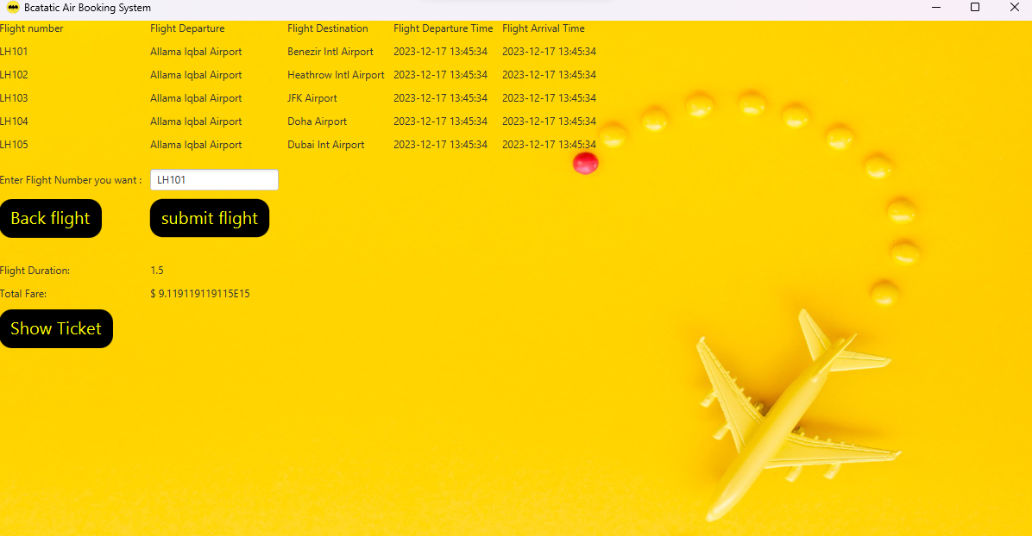

Press show ticket which displays the ticket and prints it information:

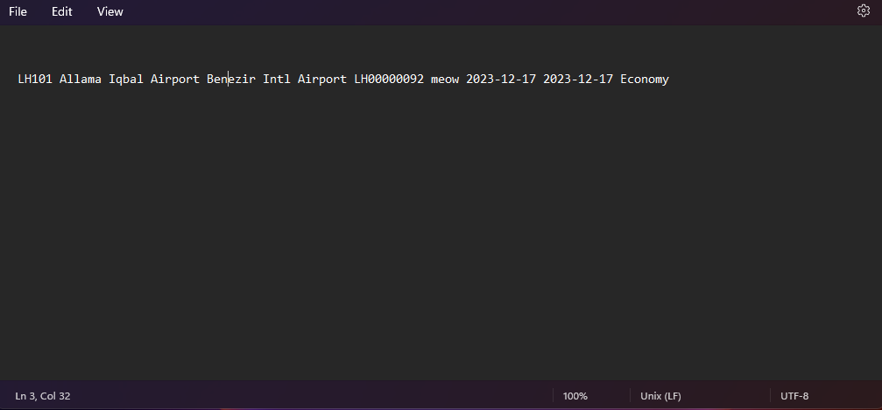

# 2.Flight schedule printing

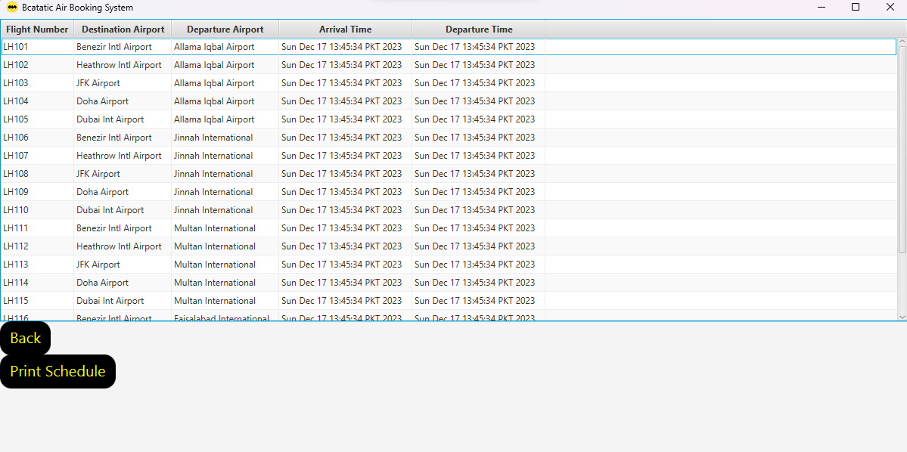

# Press button to print flight schedule

# 3.feedback record maintenance:

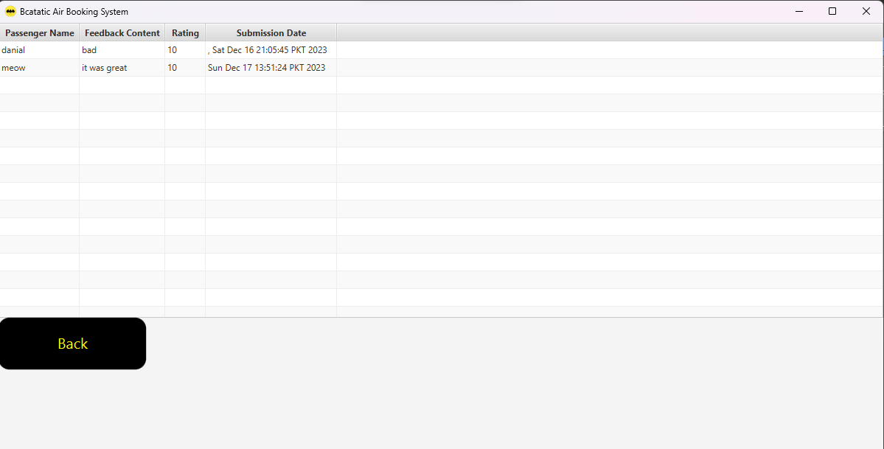

# 4.Cargo (new feature)

# Helps you determine you delivery fare of your parcel at one touch , you can visit our offices to get the parcel booked.

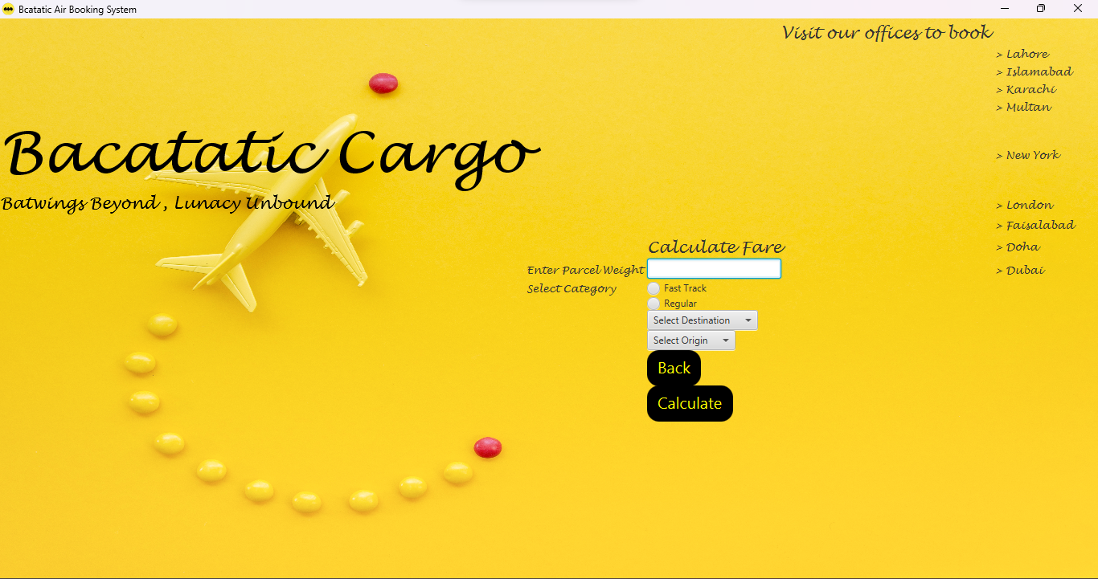

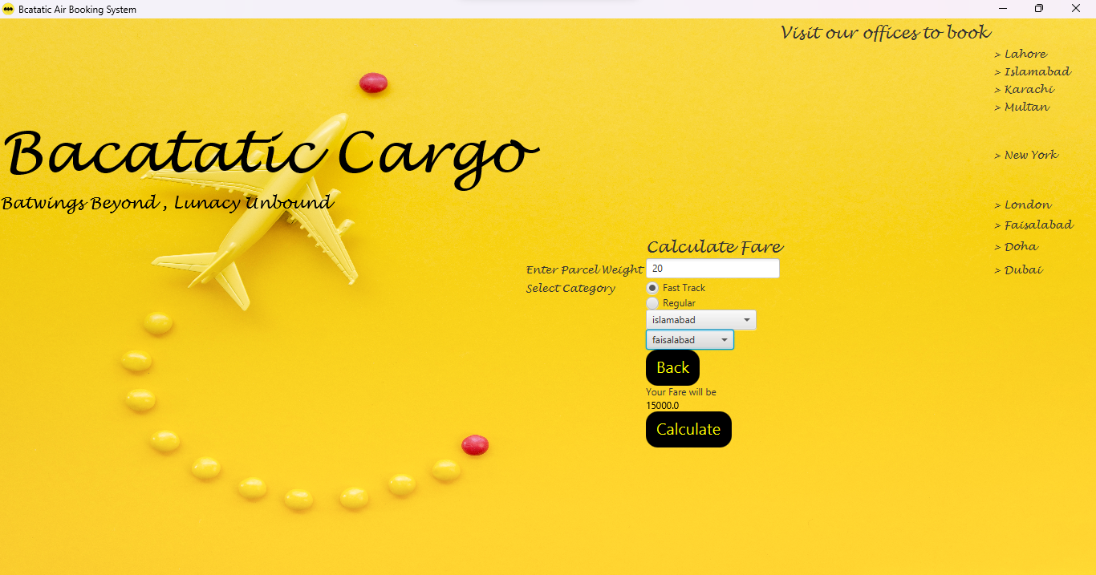

# UML diagram

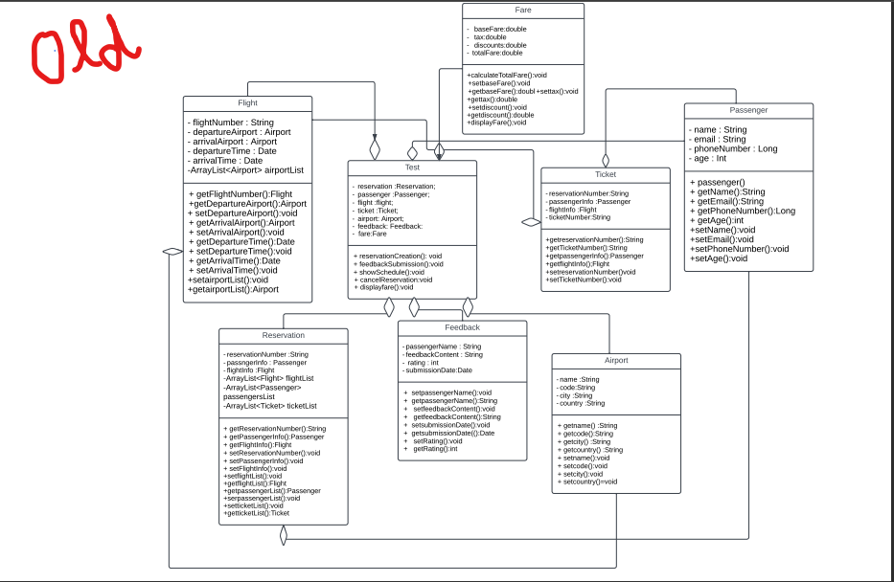

New UML diagram looks quite different from Old because of Gui , file handling and creation of exception classes. Date type attributes have changed into Strings in some classes for file handling purposes.

(new uml might not be clear because of the large size )

# New UML

